**Contact Us**

**Telephone:** +1 646 809 7465

**For general Enquiries:** [**info@pinkribbon.org**](mailto:info@pinkribbon.org)

**For Donations contact:** [**Donations@pinkribbon.org**](mailto:Donations@pinkribbon.org)

**For Affiliate information contact** [**Affiliate@pinkribbon.org**](mailto:Affiliate@pinkribbon.org)

**Fo Collaborations contact:** [**Collaborator@pinkribbon.org**](mailto:Collaborator@pinkribbon.org)

**For Partners and Corporate Partners contact:** [**Partner@pinkribbon.org**](mailto:Partner@pinkribbon.org)

**For Grants and to discuss Scientific Research contact: Grants@ pinkribbon.org**

**Find us and follow us on**

**Instagram: @pinkribboninternational**

**Facebook:** [**https://www.facebook.com/profile.php?id=61574173010505**](https://www.facebook.com/profile.php?id=61574173010505)

**Linkedin:** [**https://www.linkedin.com/company/105950858**](https://www.linkedin.com/company/105950858)

**Quick Link Donate to Us**

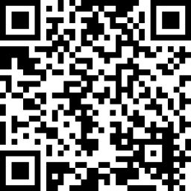

**Email:** [**info@pinkribbon.org**](mailto:info@pinkribbon.org)

**Tele/SMS: +1 646 809 7465**

**( +1 646 809 PINK)**

**PinkRibbon International PinkRibbon Inc**

**3000 Marcus Ave**

**Suite 1W5**

**New Hyde Park, NY**

**11042 -1007**

**New York, USA**

Pink Ribbon, registered on 2008,  is a public charity as defined by subparagraph (a)(5) of Section 102 (Definitions) of the Not-for-Profit Corporation Law. Pink Ribbon International is organized exclusively for charitable, educational and scientific purposes, within the meaning of Section 501(c)(3) of the Internal Revenue Code of 1986. Contributions are deductible under section 170 of the Code. Pink Ribbon is qualified to receive tax deductible bequests, devises, transfers and gifts under section 2055, 2106 and 2522 of the Code. Donations are tax deductible (EIN:  
42-1766709 DLN: 700288004).